C:\Users\prod_form\AppData\Local\Microsoft\Windows\Temporary Internet Files\Content.Word\1778_rt_sharp_short_dance_logo_art.eps

**SHARP SHORT DANCE 2018**

**ENTRIES NOW OPEN!**

**CALLING ALL YOUNG CHOREOGRAPHERS!**

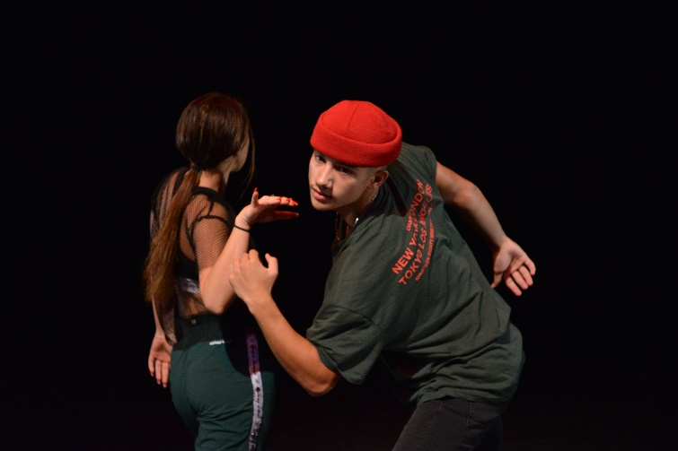FORM Dance Projects invites young choreographers and dancers to participate in *Sharp Short Dance* to be held at Riverside Theatres, Parramatta this November! The season will present numerous dance works choreographed and performed by emerging young artists.

*Sharp Short Dance*provides an opportunity for aspiring choreographers and dancers aged 21 and under to not only display their talents, but to also inspire young performers to strive for their own artistic excellence and encourage active youth participation in all genres of dance.

*Sharp Short Dance*presents new and innovative dance works, up to five minutes in length, by the dance industry’s upcoming choreographers and dancers. Each performance will go through one of three rounds of Heats, which will be judged nightly by a panel of industry professionals. The heat winners will present their works as part of the Final on Saturday 17 November 2018.

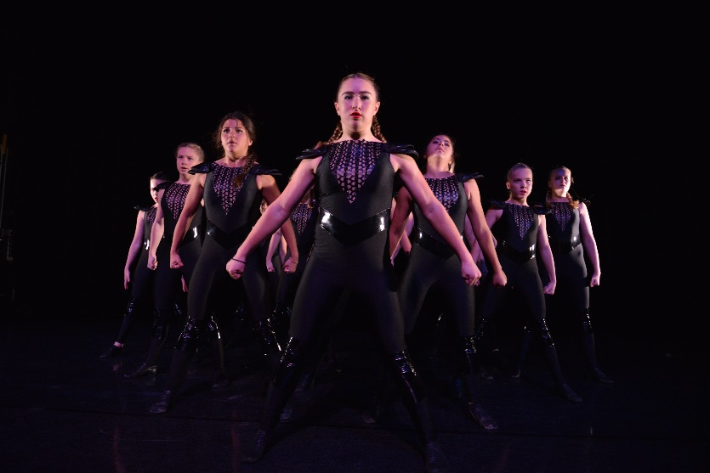All participants in *Sharp Short Dance*are eligible for sponsored awards such as Outstanding Male Performer, Outstanding Female Performer, Most Innovative Choreography, Outstanding Solo, Duet and Ensemble Performance and the Audience Choice Award. Finalists are also eligible for industry placement opportunities with companies including Sydney Dance Company’s Pre-Professional Year, Dance Makers Collective and Catapult Dance.

*“thank you again for giving me all these great opportunities! I thoroughly enjoyed Sharp Short 2017 and believe it’s fantastic for aspiring choreographers and dancers.*” Sabrina Muszynski 2017 Sharp Short Dance Winner

**FORM Dance Projects is now seeking submissions from artists to participate in this year’s season. Choreographers can enter one work into each heat, which are curated by genre:**

Heat One – Jazz, Tap and Lyrical dance works

Heat Two – Classical, Contemporary and Cultural dance works

Heat Three – Hip Hop and Street dance works

**SHARP SHORT DANCE 2018 SEASON DATES**

HEATS ONE TO THREE: 13-15 NOVEMBER 7.30PM

FINAL: 17 NOVEMBER 7.30PM

**APPLICATIONS CLOSE THURSDAY 18 OCTOBER 2018**

Photo credit: Dom O’Donnell

**SHARP SHORT DANCE 2018 GUIDELINES**

• Works must be 5 minutes or less in length.

• The piece must be an original work choreographed and performed by persons aged 21 and under.

• Entrants can submit a work for consideration to each heat (i.e. can submit more than one work in total).

Entrants must complete and submit an application for each work and are limited to one work per heat (a total of three works). Each submission requires its own application form and registration fee.

• All styles of dance will be considered, so long as the choreography is original and the participants meet the entry criteria. The entrant must indicate which heat category best reflects their choreography. If an entrant is unsure which category their work subscribes to, they may select multiple and the selection panel will then (if successful) allocate the work to a heat at their discretion.

• Works may contain movable props however; the performer/s is/are responsible for taking the props on and off stage during a performance. Transport and storage of props will not be provided by the venue.

• A CD or USB of appropriately cut music must be provided and given to the sound technician at least 30 minutes prior to the beginning of each performance and collected at the end of each performance.

• FORM Dance Projects will provide a stage manager and a lighting and sound operator.

• There will be a technical run on the day of the heat. Participants must come prepared in full costume with clear notes regarding lighting. If successful, entrants will be informed of their technical rehearsal time.

• Performances are in front of a live audience and a panel of judges. Results and prizes for each Heat and the Final will be announced directly after the performance.

• FORM Dance Projects and Riverside Theatres take no responsibility of any items that may be lost or stolen.

• **Applications are requested in DVD, Vimeo or Youtube format.** The video may be of the full work or a work-in-progress but the selection panel must get a clear understanding of the work’s style and intent from the video.

• Any participants not able to submit a DVD, Vimeo or Youtube video for legitimate reasons may still be considered for entry into the festival. Such decisions are made at the discretion of the festival organisers.

• Each application must be accompanied by a non-refundable $15 registration fee. Please see application form for payment options.

• Please send application entry form, DVD, Vimeo or Youtube link and payment to:

**FORM Dance Projects**

**Sharp Short Dance**

**PO Box 3636**

**PARRAMATTA NSW 2124**

Or scan and email to

[ssd\_Form@cityofparramatta.nsw.gov.au](mailto:ssd_Form@cityofparramatta.nsw.gov.au)

* Applications close **Thursday 18 October 2018**
* The judges are looking for innovative, newly choreographed dance works
* Prizes will be given in the following categories:
* Outstanding Male Performer
* Outstanding Female Performer
* Outstanding Solo Performance
* Outstanding Duet Performance
* Outstanding Ensemble Performance
* Most Innovative Choreography
* Audience Choice Award

**SHARP SHORT DANCE 2018 APPLICATION FORM**

Choreographer Name : \_\_\_\_\_\_\_\_\_\_\_\_\_\_\_\_\_\_\_\_\_\_\_\_\_\_\_\_\_\_\_ Age: \_\_\_\_\_\_\_\_\_\_\_\_\_\_\_\_\_\_\_\_\_\_\_\_\_\_\_\_\_\_\_\_\_\_

Choreographer Address: \_\_\_\_\_\_\_\_\_\_\_\_\_\_\_\_\_\_\_\_\_\_\_\_\_\_\_\_\_\_\_\_\_\_\_\_\_\_\_\_\_\_\_\_\_\_\_\_\_\_\_\_\_\_\_\_\_\_\_\_\_\_\_\_\_\_\_\_\_\_\_\_\_

Choreographer Phone: \_\_\_\_\_\_\_\_\_\_\_\_\_\_\_\_\_\_\_\_\_\_ Email: \_\_\_\_\_\_\_\_\_\_\_\_\_\_\_\_\_\_\_\_\_\_\_\_\_\_\_\_\_\_\_\_\_\_\_\_\_\_\_\_\_\_\_

School/College Name: \_\_\_\_\_\_\_\_\_\_\_\_\_\_\_\_\_\_\_\_\_\_\_\_\_\_\_\_\_\_\_\_\_\_\_\_\_\_\_\_\_\_\_\_\_\_\_\_\_\_\_\_\_\_\_\_\_\_\_\_\_\_\_\_\_\_\_\_\_\_\_\_\_

School College Address: \_\_\_\_\_\_\_\_\_\_\_\_\_\_\_\_\_\_\_\_\_\_\_\_\_\_\_\_\_\_\_\_\_\_\_\_\_\_\_\_\_\_\_\_\_\_\_\_\_\_\_\_\_\_\_\_\_\_\_\_\_\_\_\_\_\_\_\_\_\_\_\_\_

School/College Phone: \_\_\_\_\_\_\_\_\_\_\_\_\_\_\_\_\_\_\_\_\_\_\_\_\_\_\_\_\_\_\_ Fax: \_\_\_\_\_\_\_\_\_\_\_\_\_\_\_\_\_\_\_\_\_\_\_\_\_\_\_\_\_\_\_\_\_\_\_

School/College Contact Name: \_\_\_\_\_\_\_\_\_\_\_\_\_\_\_\_\_\_\_\_\_\_\_\_\_\_\_\_\_\_\_\_\_\_\_\_\_\_\_\_\_\_\_\_\_\_\_\_\_\_\_\_\_\_\_\_\_\_\_\_\_\_\_\_\_\_\_\_

Number of Dancers: \_\_\_\_\_\_\_\_\_\_\_\_\_\_\_\_\_\_\_ Approx. Duration of Piece: \_\_\_\_\_\_\_\_\_\_\_\_\_\_\_\_\_\_\_\_\_\_\_\_\_\_\_\_\_\_\_\_\_\_\_

Music Title/Composer: \_\_\_\_\_\_\_\_\_\_\_\_\_\_\_\_\_\_\_\_\_\_\_\_\_\_\_\_\_\_\_\_\_\_\_\_\_\_\_\_\_\_\_\_\_\_\_\_\_\_\_\_\_\_\_\_\_\_\_\_\_\_\_\_\_\_\_\_\_\_\_\_\_\_\_

Title of the Piece: \_\_\_\_\_\_\_\_\_\_\_\_\_\_\_\_\_\_\_\_\_\_\_\_\_\_\_\_\_\_\_\_\_\_\_\_\_\_\_\_\_\_\_\_\_\_\_\_\_\_\_\_\_\_\_\_\_\_\_\_\_\_\_\_\_\_\_\_\_\_\_\_\_\_\_\_\_\_\_

Cultural background of performers (Aboriginal or Torres Strait Islander, Sudanese, Indian, Chinese, Lebanese, Polish, Spanish, Armenian etc):

\_\_\_\_\_\_\_\_\_\_\_\_\_\_\_\_\_\_\_\_\_\_\_\_\_\_\_\_\_\_\_\_\_\_\_\_\_\_\_\_\_\_\_\_\_\_\_\_\_\_\_\_\_\_\_\_\_\_\_\_\_\_\_\_\_\_\_\_\_\_\_\_\_\_\_\_\_\_\_\_\_\_\_\_\_\_\_

Please choose a heat category (you may select multiple if you are unsure which the best fit for your work is):

* Heat One - jazz, tap, lyrical
* Heat Two - classical, contemporary,
* Heat Three – cultural dance, hip hop, street dance

Brief outline of the Piece: *(you may attach an additional page) \_\_\_\_\_\_\_\_\_\_\_\_\_\_\_\_\_\_\_\_\_\_\_\_\_\_\_\_\_\_\_\_\_\_\_\_\_\_\_\_\_\_\_\_\_\_\_\_\_\_\_*

Video link: \_\_\_\_\_\_\_\_\_\_\_\_\_\_\_\_\_\_\_\_\_\_\_\_\_\_\_\_\_\_\_\_\_\_\_\_\_\_\_\_\_\_\_\_\_\_\_\_\_\_\_\_\_\_\_\_\_\_\_\_\_\_\_\_\_\_\_\_\_\_\_\_\_\_\_\_\_\_\_\_\_\_\_\_ (Please also include this in the body of your email upon submission if submitting via email)

**Please also attach a brief biography of each dancer and choreographer outlining any previous dance experience.**

**Payment Options**

* cheque or money order for $15 payable to **Riverside Theatres** (please attach to form)
* credit card (Visa, MasterCard or Amex) please complete the following credit card payment form:

PLEASE CHARGE THE $15 APPLICATION FEE TO MY (please tick):

VISA MASTERCARD AMEX

CARD NO:\_\_\_\_\_\_\_\_\_\_\_\_\_\_\_\_\_\_\_\_\_\_\_\_\_\_\_\_\_\_\_\_\_\_\_\_\_\_\_\_\_\_\_\_\_\_\_\_\_\_\_ EXPIRY DATE:\_\_\_\_\_\_\_\_\_\_\_\_\_\_\_\_\_\_\_\_\_

CARDHOLDERS NAME:\_\_\_\_\_\_\_\_\_\_\_\_\_\_\_\_\_\_\_\_\_\_\_\_\_\_\_\_\_\_\_\_\_\_\_\_\_\_\_\_\_\_\_\_\_\_\_\_\_\_\_\_\_\_\_\_\_\_\_\_\_\_\_\_\_\_\_\_\_\_\_\_\_\_

Please send application entry form, DVD, Vimeo or Youtube link and payment via email [ssd\_Form@cityofparramatta.nsw.gov.au](mailto:ssd_Form@cityofparramatta.nsw.gov.au)or post to:

**FORM Dance Projects**

**Sharp Short Dance**

**PO Box 3636**

**PARRAMATTA NSW 2124**

**APPLICATIONS CLOSE THURSDAY 18 OCTOBER 2018**

*For any enquiries contact FORM Dance Projects on 9806 5609 or email:* [ssd\_Form@cityofparramatta.nsw.gov.au](mailto:ssd_Form@cityofparramatta.nsw.gov.au)

**SHARP SHORT DANCE 2018 REGISTRATION INFORMATION**

How did you hear about *Sharp Short Dance?*

\_\_\_\_\_\_\_\_\_\_\_\_\_\_\_\_\_\_\_\_\_\_\_\_\_\_\_\_\_\_\_\_\_\_\_\_\_\_\_\_\_\_\_\_\_\_\_\_\_\_\_\_\_\_\_\_\_\_\_\_\_\_\_\_\_\_\_\_\_\_\_\_\_\_\_\_\_\_\_\_\_\_\_\_\_\_\_\_\_\_\_\_

Do you or any of the performers in your work identify as:

* Aboriginal or Torres Strait Islander
* Culturally and/or Linguistically Diverse
* A person with disability

What region do you live in (please tick one region only):

* Eastern Sydney
* Western Sydney
* Central West
* Mid North Coast
* North Western
* Far West
* Richmond Tweed
* Hunter
* Murrumbidgee
* South Eastern
* Illawarra
* Northern
* Interstate (please write area): \_\_\_\_\_\_\_\_\_\_\_\_\_\_\_\_\_\_\_\_\_\_\_\_\_\_\_\_\_\_\_\_\_\_\_\_\_\_\_\_\_\_\_\_\_\_\_\_\_\_\_\_\_\_\_\_\_\_\_\_\_\_\_